Covid19 Pakistan - Rise in Pandemic - An Analysis of March and April

**Pakistan in top 20 with increasing corona patients.**

“**All countries need to review their strategies now,**” Dr. Michael J. Ryan, WHO Informal Advisory Group member.

Coronavirus in Pakistan began when 2 persons were diagnosed on 26 Feb 2020. Since then, large number of cases throughout the four provinces were reported and began increasing at a high rate and reached their peak in May 2020.

In Order to analyse the situation of the pandemic in Pakistan, I had to know the reasons behind the sudden increase in the number of reported patients as well as death rate.

I have taken [Covid19-Pk](http://shorturl.at/bN459) as my dataset for analysis, performed data-cleaning using python and made visualizations using **Power Bi and Tableau.**

 According to dataset, with a difference of only **one month**, the death rate was almost **17.5 times higher in Punjab and KP.** Unfortunately it was **30 times higher in Sindh** in April as compared to March. Following bar chart shows difference in one month of corona deaths in 4 major provinces of Pakistan.

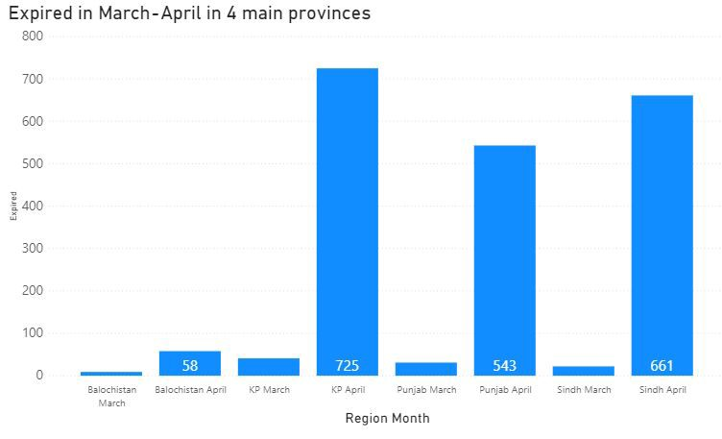

[**Microsoft Power BI**  
*Edit description*app.powerbi.com](https://app.powerbi.com/reportEmbed?reportId=636285ad-5807-43e9-b3ca-ceaa5c3b101f&autoAuth=true&ctid=75df096c-8b72-48e4-9b91-cbf79d87ee3a&config=eyJjbHVzdGVyVXJsIjoiaHR0cHM6Ly93YWJpLXdlc3QtZXVyb3BlLXJlZGlyZWN0LmFuYWx5c2lzLndpbmRvd3MubmV0LyJ9)

**22nd of April** proved to be the day with **highest death rate of 224** and **highest number of patients still admitted of 2779** throughout the country. But the same day proved *lucky* enough for **2337 corona patients who recovered** and were discharged in Pakistan.

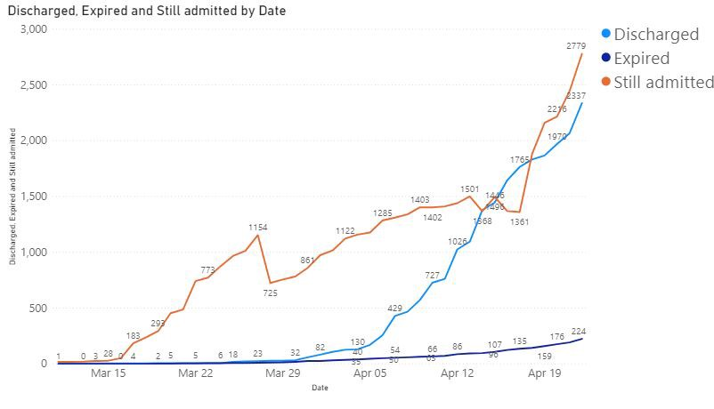

**1290,** the largest number of patients ever **admitted in a single day**, were on 12th of April in **Punjab**. **KP had only a total of 9 patients** which were admitted in the two months but surprisingly the province with **highest death rate was also KP** (as in graph 1).

By the end of April, Punjab and Sindh remained the top two in having the largest number of admitted patients. Baluchistan, however, had a decline in patients admitted.

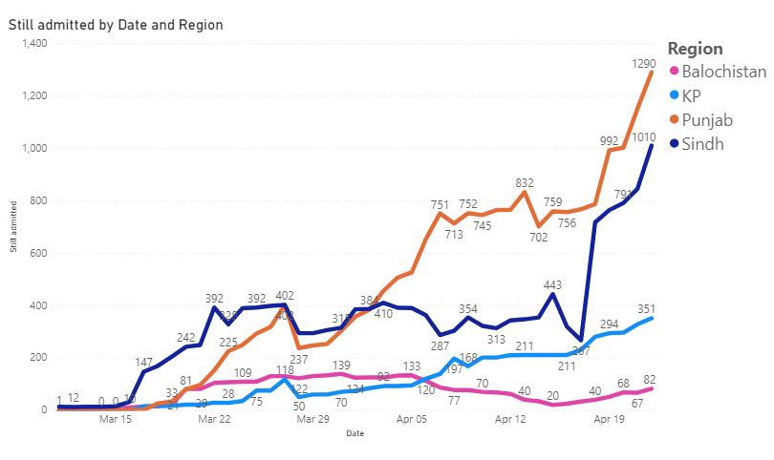

**Punjab had the largest rate of test performed about 775,000+** as well as with **largest positive cases as of 57000+**, Sindh being second most in having tests and positive cases while Baluchistan, GB, AJK and ICT had low percentages of positive cases as compared to the tests being done.

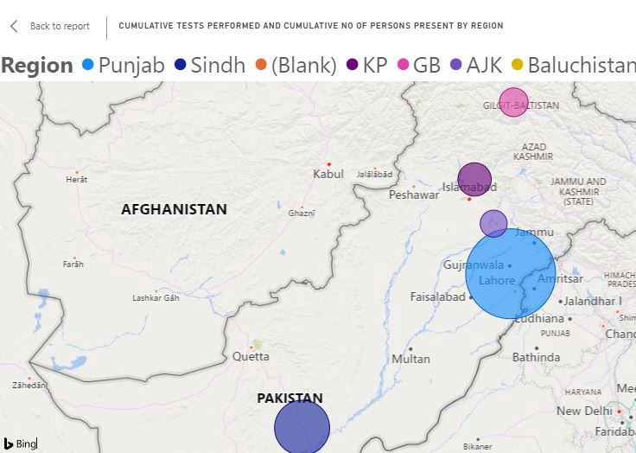

[**Microsoft Power BI**  
*Edit description*app.powerbi.com](https://app.powerbi.com/reportEmbed?reportId=4d39bb7f-b966-47d2-9b1a-1690412bee3d&autoAuth=true&ctid=75df096c-8b72-48e4-9b91-cbf79d87ee3a&config=eyJjbHVzdGVyVXJsIjoiaHR0cHM6Ly93YWJpLXdlc3QtZXVyb3BlLXJlZGlyZWN0LmFuYWx5c2lzLndpbmRvd3MubmV0LyJ9)

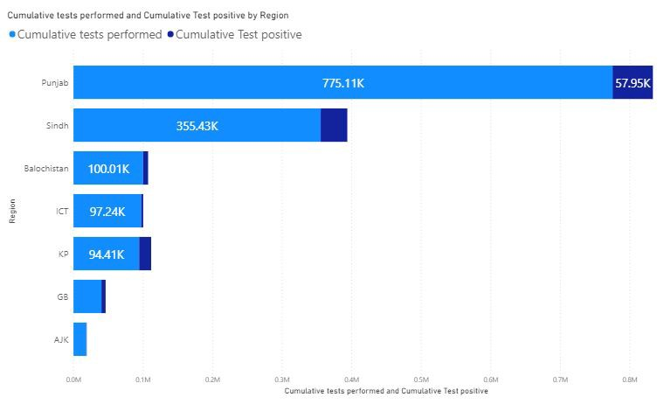

[**Microsoft Power BI**  
*Edit description*app.powerbi.com](https://app.powerbi.com/reportEmbed?reportId=636285ad-5807-43e9-b3ca-ceaa5c3b101f&autoAuth=true&ctid=75df096c-8b72-48e4-9b91-cbf79d87ee3a&config=eyJjbHVzdGVyVXJsIjoiaHR0cHM6Ly93YWJpLXdlc3QtZXVyb3BlLXJlZGlyZWN0LmFuYWx5c2lzLndpbmRvd3MubmV0LyJ9)

According to my observations and analysis of the entire data set as well as the situation in Pakistan, the outspread of corona began when travellers from outside flooded in, from **China and Iran**, in large numbers. From 25 to 31st March each day 234 persons were suspected of corona when screened, out of thousands of travelers.

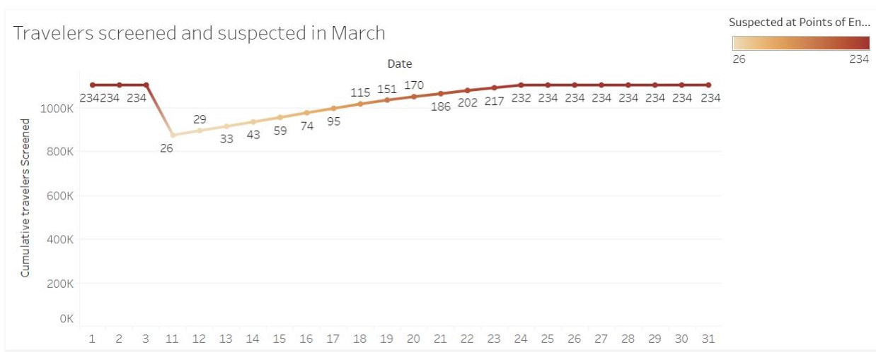

[**Tableau Public**  
*Edit description*public.tableau.com](https://public.tableau.com/views/2_15894858044050/Sheet1?:display_count=y&:origin=viz_share_link)

This graph is only showing the returnees who were **suspected of corona** and were advised self quarantine in the first 22 days of March.

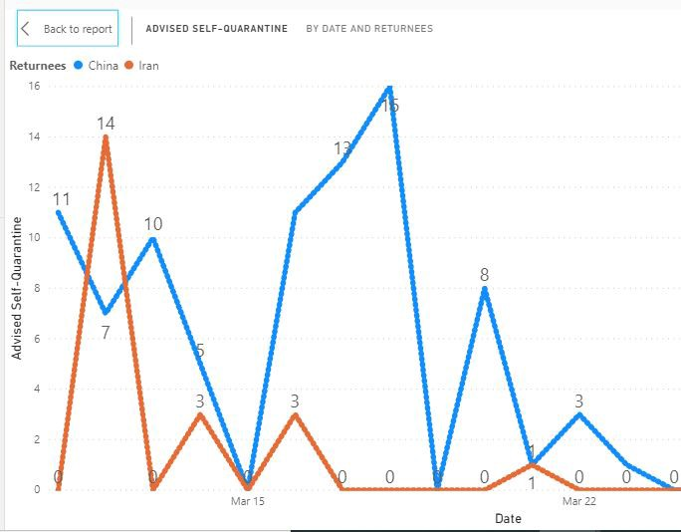

[**Microsoft Power BI**  
*Edit description*app.powerbi.com](https://app.powerbi.com/reportEmbed?reportId=d7329a17-b104-479d-bad3-126db8a984cb&autoAuth=true&ctid=75df096c-8b72-48e4-9b91-cbf79d87ee3a&config=eyJjbHVzdGVyVXJsIjoiaHR0cHM6Ly93YWJpLXdlc3QtZXVyb3BlLXJlZGlyZWN0LmFuYWx5c2lzLndpbmRvd3MubmV0LyJ9)

From thousands of returnees, large number of calls were received for help. The light blue bar represents calls from returnees from China only similarly dark blue bars represent calls from returnees of Iran. The orange line indicates follow up calls made by the both.

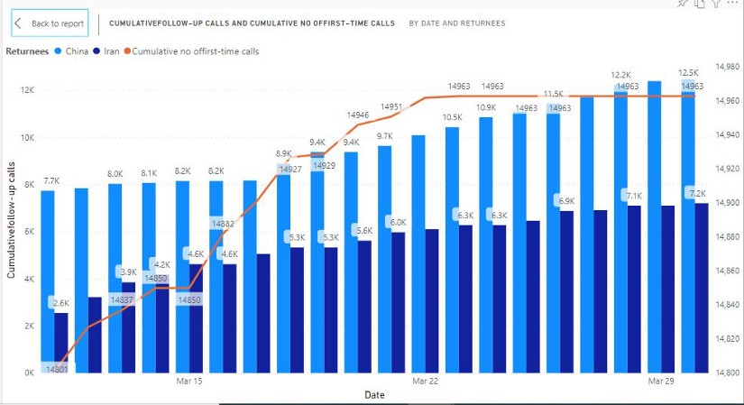

[**Microsoft Power BI**  
*Edit description*app.powerbi.com](https://app.powerbi.com/reportEmbed?reportId=d7329a17-b104-479d-bad3-126db8a984cb&autoAuth=true&ctid=75df096c-8b72-48e4-9b91-cbf79d87ee3a&config=eyJjbHVzdGVyVXJsIjoiaHR0cHM6Ly93YWJpLXdlc3QtZXVyb3BlLXJlZGlyZWN0LmFuYWx5c2lzLndpbmRvd3MubmV0LyJ9)

Quarantine facilities as of March-April, were the highest in KP, making about 50% of entire Pakistan’s quarantine centres. Punjab with highest population had only 2% of quarantine centres making it very dangerous for citizens living there.

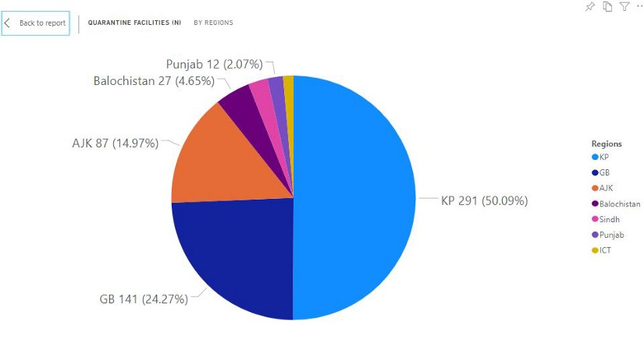

[**Microsoft Power BI**  
*Edit description*app.powerbi.com](https://app.powerbi.com/reportEmbed?reportId=4d39bb7f-b966-47d2-9b1a-1690412bee3d&autoAuth=true&ctid=75df096c-8b72-48e4-9b91-cbf79d87ee3a&config=eyJjbHVzdGVyVXJsIjoiaHR0cHM6Ly93YWJpLXdlc3QtZXVyb3BlLXJlZGlyZWN0LmFuYWx5c2lzLndpbmRvd3MubmV0LyJ9)

The quarantine facilities as in pie chart were maximum in KP but surprisingly **Punjab with 8000+ patients had only 12 quarantine centres** for the patients to keep isolated.

As discussed earlier, the number of arrivals were increasing which led to spread of corona. Only in KP the number of arrival during 24 hours was near to 600. Punjab had highest people home quarantined due to the lack of enough quarantine centres, taking the scale above 50,000.

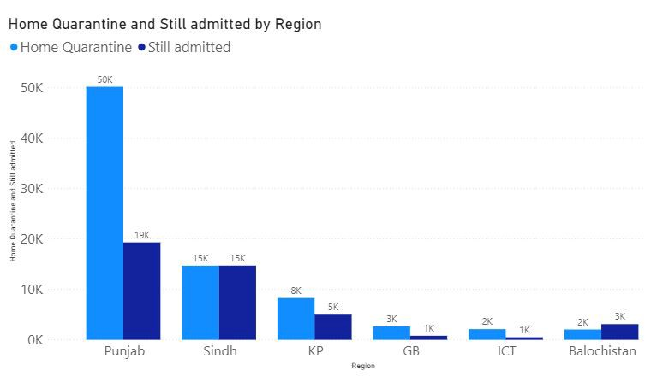

[**Microsoft Power BI**  
*Edit description*app.powerbi.com](https://app.powerbi.com/reportEmbed?reportId=636285ad-5807-43e9-b3ca-ceaa5c3b101f&autoAuth=true&ctid=75df096c-8b72-48e4-9b91-cbf79d87ee3a&config=eyJjbHVzdGVyVXJsIjoiaHR0cHM6Ly93YWJpLXdlc3QtZXVyb3BlLXJlZGlyZWN0LmFuYWx5c2lzLndpbmRvd3MubmV0LyJ9)

Coronavirus is getting worse throughout the world and in coming days it is expected to have an entirely different world after the end of pandemic. It is advised for Pakistanis to follow the SOP’s set by Pakistan’s government to limit the spread of corona.